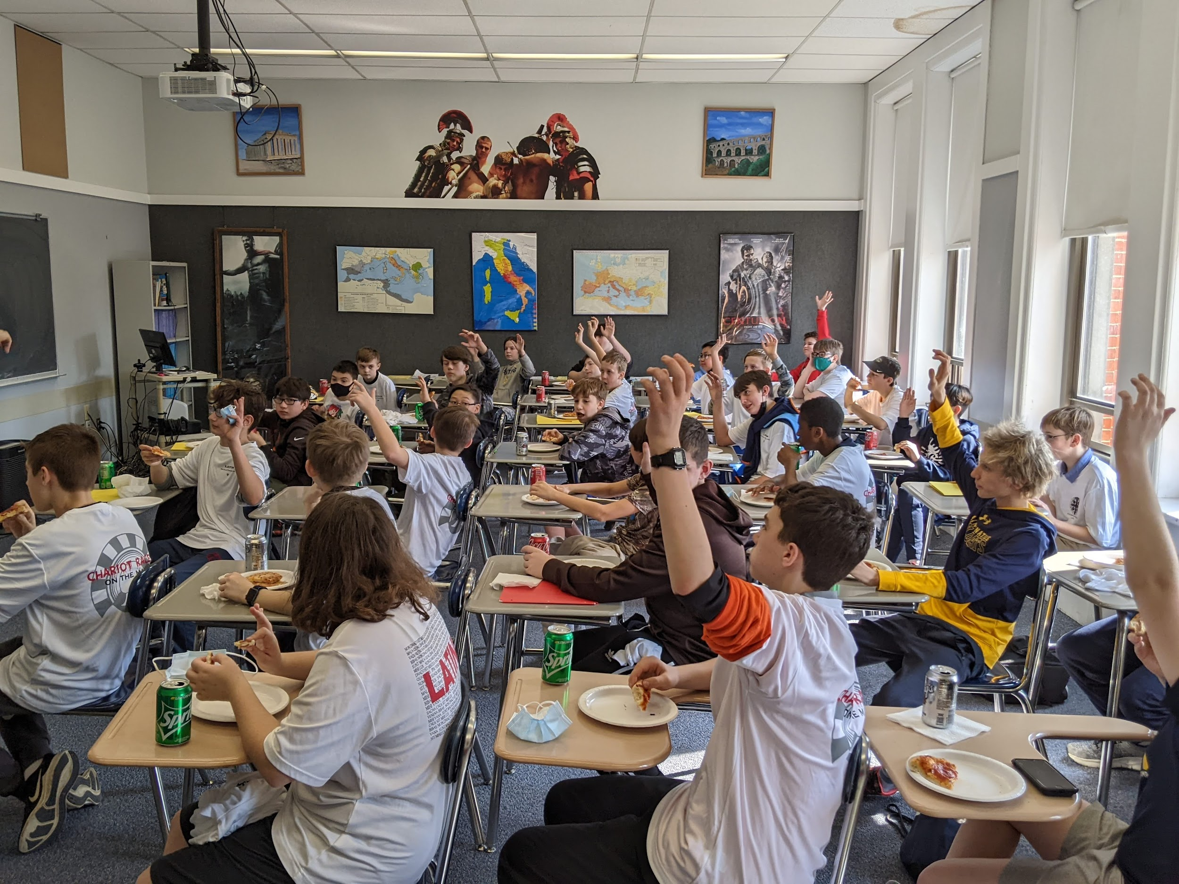

**Sign up for the**

**Grade School Latin Program!**

**Saturdays, 1:00 - 2:00 pm**

**October 21 October 28**

**November 4 November 11**

**Register online:**



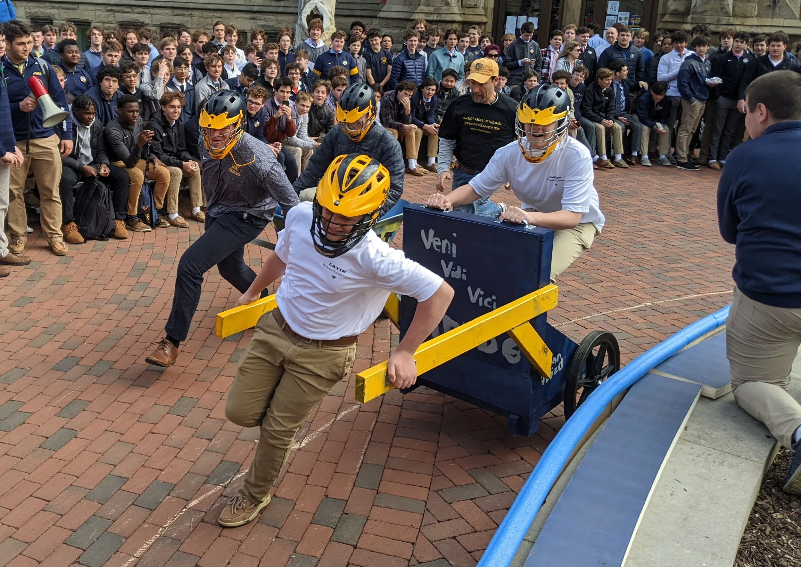

**COME JOIN OUR LEGION:**

**Did you ever want to learn Latin, ride in a chariot, shoot a ballista, or launch a catapult?**

**Then the Grade School Latin Program is for you.**

**The course is FREE!!!**

Register online

[www.ignatius.edu/grade_school](http://www.ignatius.edu/grade_school)

or call 651-0222 ext. 253

or e-mail jzebrak@ignatius.edu